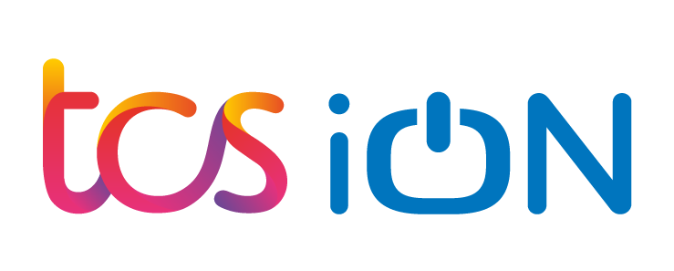

#### **Project Report**

Customer Satisfaction Survey Dashboard

**Created by AKHIL.K**

|  |  |  |  |  |
| --- | --- | --- | --- | --- |
| **Start Date** | **End Date** | **Total Effort (hrs.)** | **Project Environment** | **Tools used** |
| 23/03/2023 | 05/04/2023 | 50 hours including holidays | * **Browser**: Google Chrome Driver * **Network/Wi-Fi**: Asianet Broadband * **Operating system**: Windows 10 * **System**: Lenovo 81D6 | Eclipse ide,, Apache Tomcat, PostgreSQL |

|  |  |
| --- | --- |
| **Internship Project Title** | **Customer Satisfaction Survey Dashboard** |
| **Name of the Company** | **TCS iON** |
| **Name of the Industry Mentor** | **Sridhar** |
| **Name of the Institute** | **ICT Academy of Kerala** |

**ACKNOWLEDGEMENTS**

I think the TCSiON internship will enhance my learnings about Java programming. I find it a great pleasure to be able to project on TCSiON.

I would like to express my gratitude towards my parents and academic mentor, for their kind co-operation and encouragement which help me complete this project.

I would like to express my special gratitude and thanks to my industry mentor for giving me such attention and time.

**Objective**

The objective of this project is to develop Web UI based customer feedback monitoring and satisfaction survey system with dynamic dashboards powered with Java.

1. ﻿﻿﻿To develop an online system for customer feedback monitoring and analysis.
2. ﻿﻿﻿Design Web Ul for users to easily access the system and provide feedback related to the projects/products for analysis.
3. ﻿﻿﻿Design dynamic dashboards that would provide the overall analysis of customer satisfaction survey of different products/projects/categories and more.

**Introduction**

To develop web-ui based automated customer satisfaction survey system comprising of dynamic dashboards to show the feedback status of different products/projects using java centric languages.

Background: Feedback analysis and customer satisfaction survey of projects/products are extremely important with respect to the business continuity and brand value of the projects/products. Participants need to develop a web -ui based feedback capturing system of projects/products and provide an analysis in a dashboard view of the products/projects. This project developed can form a part of Project Management Tool.

Brief: The system to be developed would involve all the processes required to design a web-based customer satisfaction

Survey system which may operate individually or may be integrated with other project management tool. Java based components like Servlet, SP, JDBC, REST API, etc. may be used as appropriate.

**Documentation**

Lots of documentation is involved in software development, The Figure 3-3. In this document, we will go through all the documentation needed in the different phases involved in software development. Some important documents are:

• SRS – Software Requirements Specifications

A document stating what an application must accomplish

• SDD – Software Design Document

A document describing the design of a software application

• STP - Software Test Plan

Documentation stating what parts of an application will be tested, and the schedule of when the testing is to be performed

• STD - Software Test Documentation

Contents: Introduction, Test Plan, Test Design, Test Cases, Test procedures, Test Log, …, Summary

**Internship Activities**

The internship Project is to be completed in four phases

**Stage-1: Project Creation & Role assignment for satisfaction survey**

1. ﻿﻿﻿Login for admin and participant users. Default admin user should be created by the system.
2. ﻿﻿﻿The system should have the ability to allow the admin(s) to create projects/products and define KPIs, metrics, dimensions and measures accordingly.
3. ﻿﻿﻿The system should allow the admin(s) to create users and assign roles to the participants and tag to projects.

**Stage-2: Web-Ul for capturing feedback**

1. ﻿﻿﻿Develop web-user interface to capture feedback as per the metrics/KPIs defined for the project. The system should have the capability to auto-generate user interfaces as depending upon the project metrics defined.
2. ﻿﻿﻿The generated web user-interface to be tagged to the participants entitled to give feedback for the project/product.

Stage-3: Generate Dynamic Dashboard:

1. ﻿﻿﻿Develop dynamic dash board comprising of graphs/charts that would reflect the customer satisfaction survey reports of the projects/products.
2. ﻿﻿﻿The dashboard should have the capability to select projects/products at runtime to display the results.

Pre-configuration:

MySQL database must be created with appropriate tables and fields to support the project areas like:

i) Users and Roles

ii) Projects/products of different types.

ill) Metrics/KPIs iv) User feedbacks

• Additional tables may be created if required to support dynamic report generation for analysis.

**Approach**

The Below Diagram Shows The Approach of the Software Development Life Cycle.



The Software Development Process is the structured approach to developing software for a system or project, sometimes called the Software Development Life Cycle (SDLC). Several approaches can be used, including waterfall, spiral, Agile, and incremental development. These different approaches will focus the testing effort at different points in the development process. However, each approach is composed of the same basic steps of development. The incremental development approach typically forms the basis for software development within the larger systems level of [Evolutionary Acquisition](https://acqnotes.com/acqnote/acquisitions/evolutionary-acquisitions).

### Types of Software Development Approaches

The Software Development Approaches below show how the various tasks related to software development can be organized. Typical approaches or paradigms encountered in software development include waterfall, incremental, and spiral as described below. The incremental development approach typically forms the basis for software development within the larger systems-level of [Evolutionary Acquisition (EA)](http://acqnotes.com/acqNote/evolutionary-acquisitions). There are four main types of software development approaches which are:

* **Waterfall Approach**
* **Incremental Approach**
* **Spiral Approach**
* **Agile (Scrum**

Now a days commonly most of the cases we Follow the Agile Method.

### Agile and Scrum Approach: The Agile software development process and its most popular method, Scrum, use a dynamic and iterative way to build software. In contrast to the strict, sequential flow of the Waterfall process, cross-functional teams in Agile work in “Sprints” of a week or a few months to build and release software that customers can use and give feedback on. Agile is all about moving quickly, putting out new versions often, and responding to what your users really need, even if that goes against what you had planned. This means you don’t need a full list of requirements and a full SOW before starting work. Instead, you move in one direction with the idea that you will change directions along the way.

### Flow of the project

1. First created a login page using java servlet and PostgreSQL database.
2. After that it has two options if a user will give his username and password it will redirect him/her to the feedback page where he can give feedback about the products.
3. If the admin will log in it will redirect him/her to the admin page where he can add products or assign roles to the user.
4. After all this our main task is to connect the servlet code with the database where we can store our data.
5. Lastly the dashboard, we have created the dashboard on the admin page only where he will be able to see the metrics, KPI and feedback of the products by the customer.

### Challenges

### Software development plays a crucial role in this sector and is influenced directly by many factors. These include changing technology, market conditions, growing complexities, and the rising challenges in software development projects.

### 10 Common Software Development Challenges Given Below

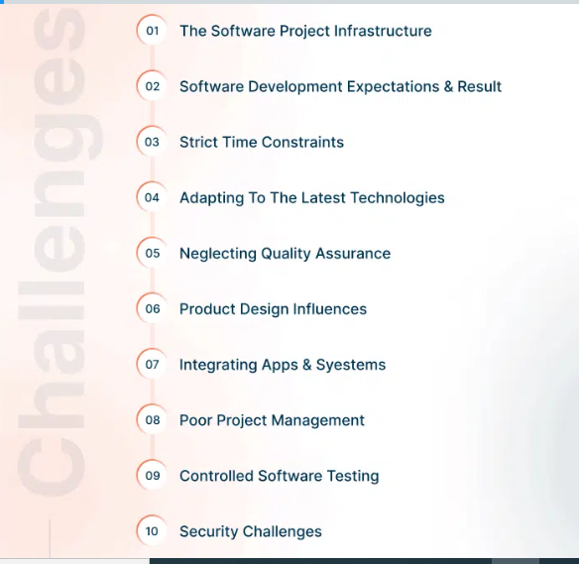

**Result**



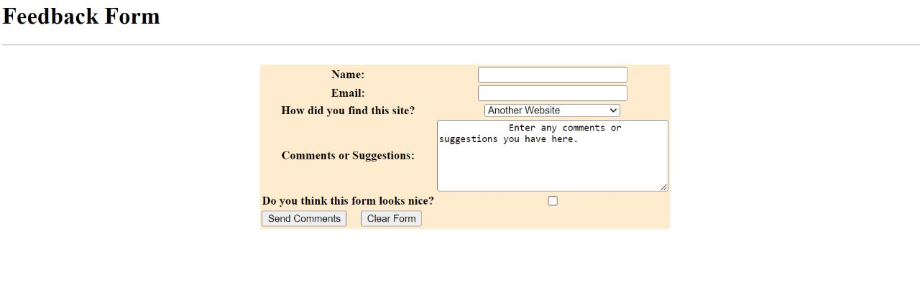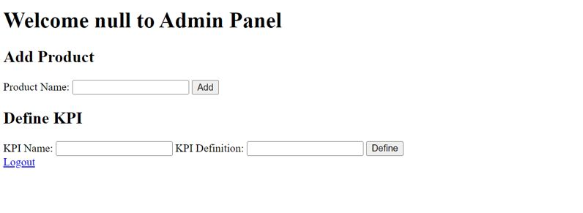

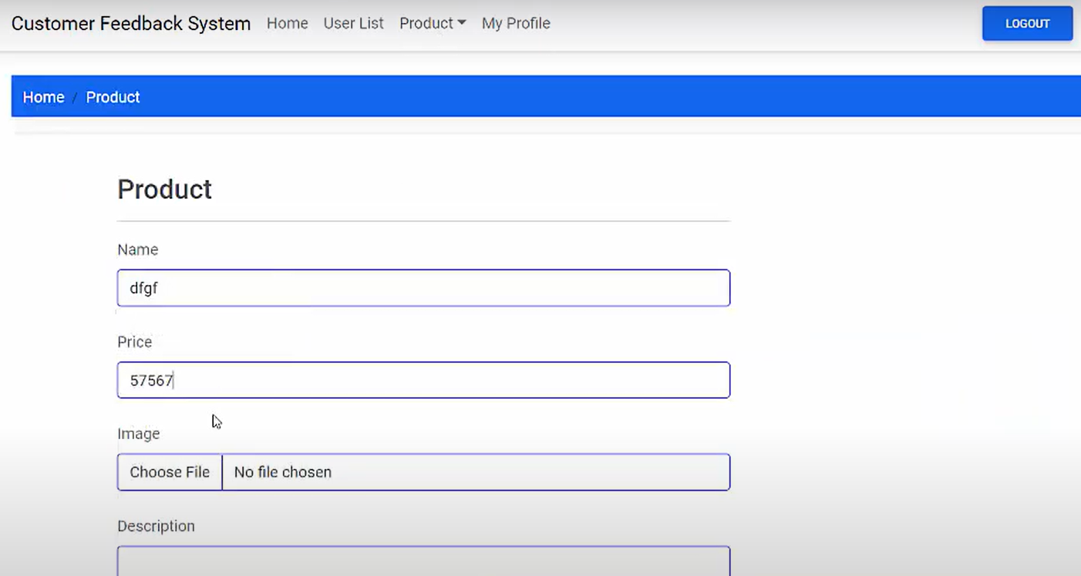

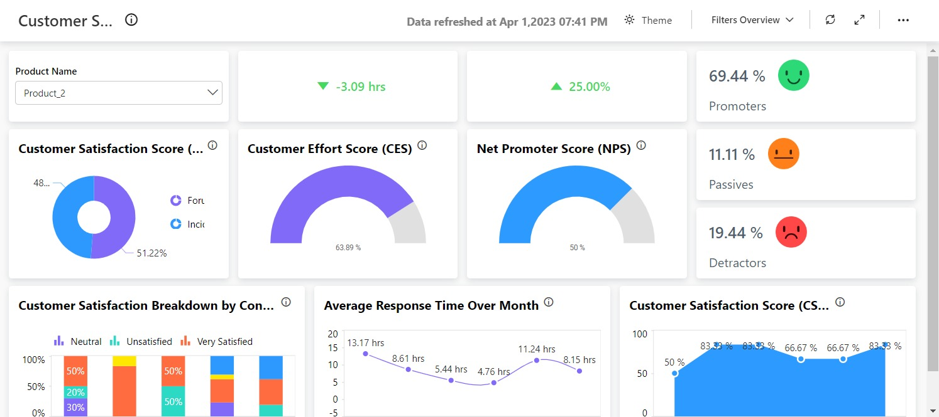

**Reflections on the Internship**

* After completing the First Milestone I was able to get a good knowledge and learning SDLC and java programming.
* Studied about flow of the SDLC
* Studied about different Type IDE. Choose Eclipse Ide for doing Project
* Studied about how to create applications using Eclipse and maven.
* Experience about the real case of a project

**Recommendations:** if it is possible to conduct a weekly Sprint meeting would helped improve work flow and clear doubts.

**Conclusion**

Completing The Project Get an idea about how the developing act in a real case Scenario. Studied about the Different Type ide and how to create applications using java. As a fresher The TCSiON platform is so intern friendly and the links that provide was really helpful for our project.

Studied about how to create GitHub account and how to push files to git hub.

The digital discussion room help to share my ideas and solve my doubts and also activity Report was speed up flow of my intern project.

**Links**

**Google drive:** [**https://drive.google.com/drive/folders/1u8bCVJQ3fh9t4kBj_iM61UrYoTfbCx-_?usp=sharing**](https://drive.google.com/drive/folders/1u8bCVJQ3fh9t4kBj_iM61UrYoTfbCx-_?usp=sharing)

**Git Hub Repository Link:** [**https://github.com/Akhilktvk/Customer-Satisfaction-Survey-Dashboard.git**](https://github.com/Akhilktvk/Customer-Satisfaction-Survey-Dashboard.git)